**Taaha Hussain Khan**

**L1F21BSCS0917**

**Graded Lab 03**

**Graded Lab 03(a)**

**Inner Joins**

Use Classic Model Schema

1. Write a Query that retrieves each employee’s extension with the phone which he use, using inner join.

**SELECT e.extension ,o.phone**

**FROM employees as e**

**INNER JOIN Offices as o**

**ON o.officecode = e.officecode;**



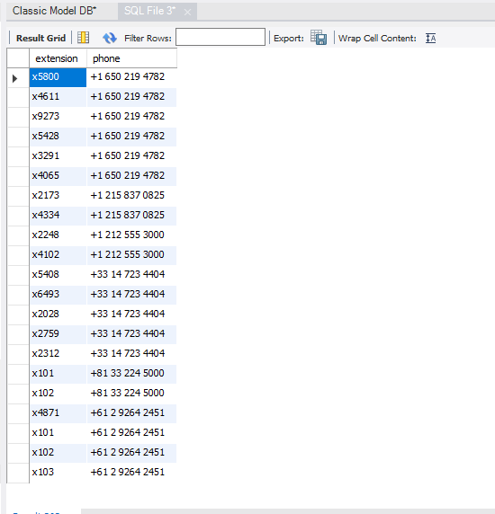

1. Write SQL query that shows those customers names and address whose payment amount is more than 30000 using inner join.

**SELECT c.customerName , c.addressLine1,c.addressLine2**

**FROM Customers as c**

**INNER JOIN payments as p**

**ON c.customerNumber = p.customerNumber**

**WHERE p.amount > 30000;**

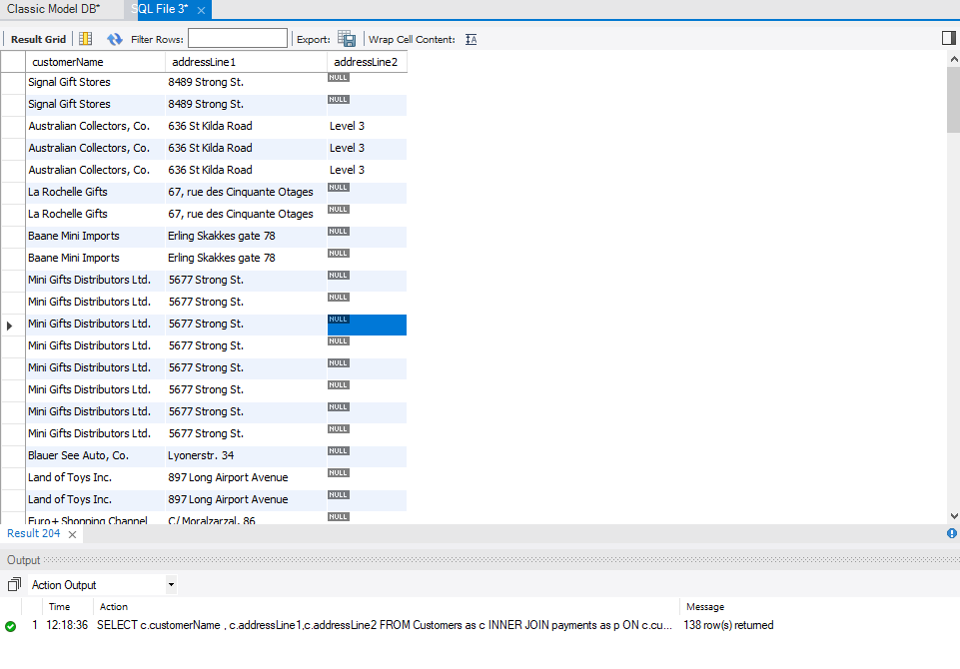

1. Write an SQL query that retrieves Product code and Product names with the Ordered quantity less than 50.

**SELECT p.productCode, p.productName,ord.quantityOrdered**

**FROM products AS p**

**JOIN orderdetails AS ord**

**ON p.productcode = ord.productcode**

**WHERE ord.quantityOrdered < 50;**

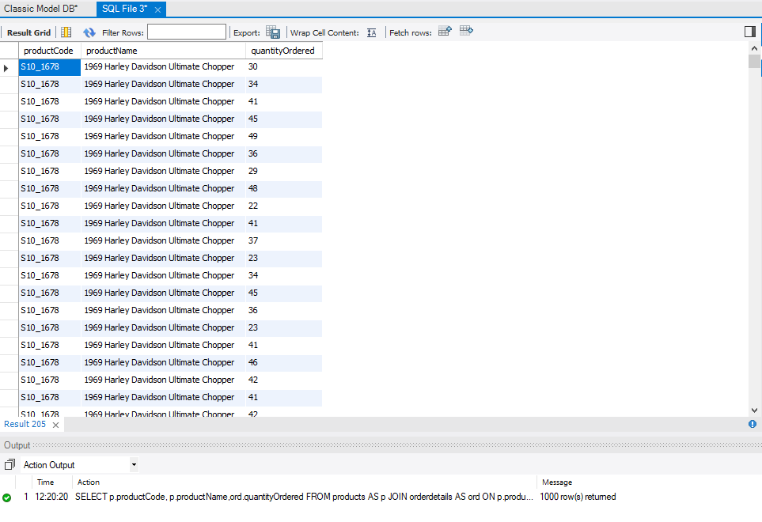

1. Write Inner Join SQL query that retrieves employee’s names with job titles whose offices located in Sydney.

**SELECT e.firstname,e.lastname,e.jobTitle**

**FROM Employees as e**

**JOIN offices AS o**

**ON e.officecode = o.officecode**

**WHERE o.city = 'Sydney';**

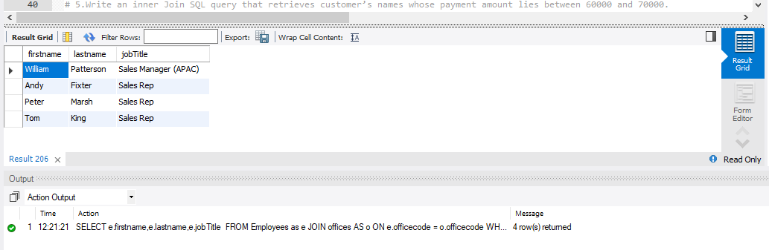

1. Write an inner Join SQL query that retrieves customer’s names whose payment amount lies between 60000 and 70000.

**SELECT c.customerName**

**FROM Customers as c**

**INNER JOIN payments as p**

**ON c.customerNumber = p.customerNumber**

**WHERE p.amount > 60000 AND p.amount < 70000;**

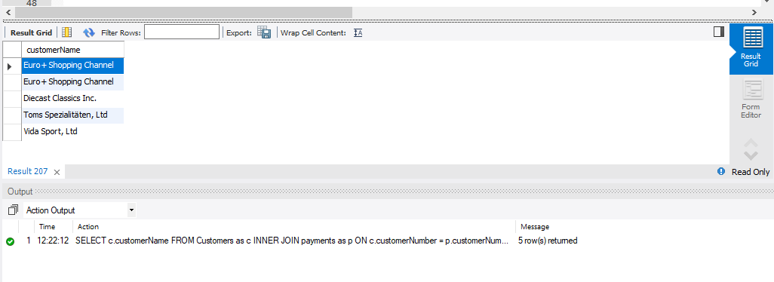

1. Write SQL query that retrieves names of those employees whose offices located in cities having name starts with ‘S’;

**SELECT e.firstname,e.lastname**

**FROM Employees as e**

**JOIN offices AS o**

**ON e.officecode = o.officecode**

**WHERE o.city LIKE 'S%';**

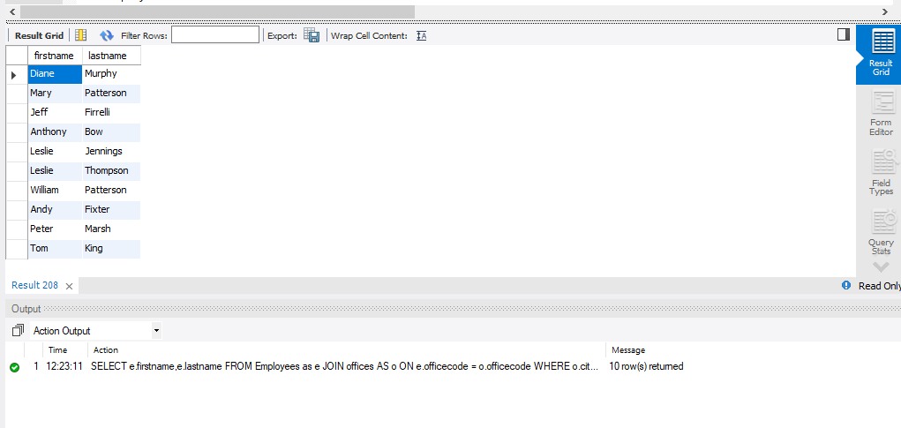

1. Write a SQL query that retrieves the complete record of all the employees whose territory is Japan.

**SELECT e.\***

**FROM Employees as e**

**JOIN offices AS o**

**ON e.officecode = o.officecode**

**WHERE o.territory = 'Japan';**

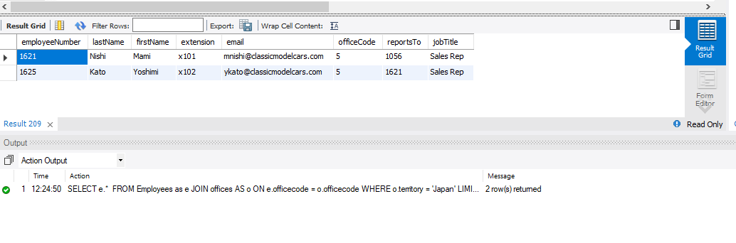

1. Write a query that retrieves the status and comments of customers with their name whose shipped date is in year 2003.

**SELECT ord.status , ord.comments , c.customername**

**FROM Customers as c**

**JOIN orders as ord**

**ON ord.customernumber = c.customernumber**

**WHERE ord.shippedDate LIKE '2003%';**

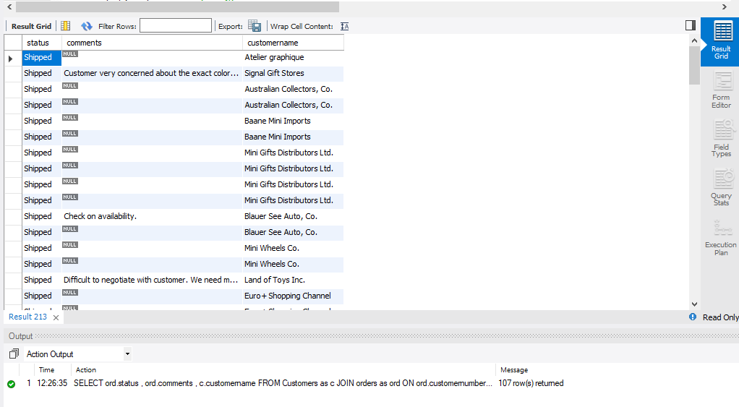

1. Write a query that display text description of those products whose name contains “Harley”

**SELECT pl.textDescription**

**FROM productLines AS pl**

**JOIN products as pr**

**ON pl.productline = pr.productline**

**WHERE pr.productName LIKE '%Harley%';**

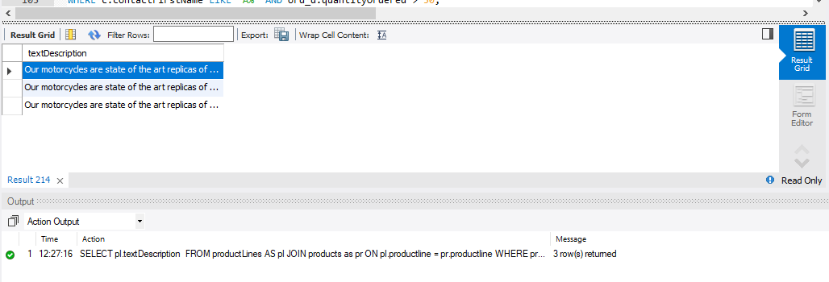

1. Write SQL query to retrieve the order numbers of those customers whose contact first name starts with A and the quantity ordered is greater than 50.

**SELECT ord.orderNumber**

**FROM orders as ord**

**JOIN customers as c**

**ON c.customerNumber = ord.customerNumber**

**JOIN orderdetails as ord_d**

**ON ord_d.orderNumber = ord.orderNumber**

**WHERE c.contactFirstName LIKE 'A%' AND ord_d.quantityOrdered > 50;**

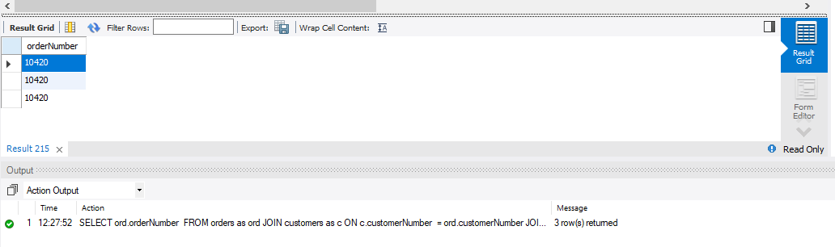

**use classicmodels;**

**# 1.Write a Query that retrieves each employee’s extension with the phone which he use, using inner join.**

**#desc Employees;**

**SELECT e.extension ,o.phone**

**FROM employees as e**

**INNER JOIN Offices as o**

**ON o.officecode = e.officecode;**

**#2. Write SQL query that shows those customers names and address whose payment amount is more than 30000 using inner join.**

**SELECT c.customerName , c.addressLine1,c.addressLine2**

**FROM Customers as c**

**INNER JOIN payments as p**

**ON c.customerNumber = p.customerNumber**

**WHERE p.amount > 30000;**

**# 3. Write an SQL query that retrieves Product code and Product names with the Ordered quantity less than 50.**

**SELECT p.productCode, p.productName,ord.quantityOrdered**

**FROM products AS p**

**JOIN orderdetails AS ord**

**ON p.productcode = ord.productcode**

**WHERE ord.quantityOrdered < 50;**

**# 4. Write Inner Join SQL query that retrieves employee’s names with job titles whose offices located in Sydney.**

**SELECT e.firstname,e.lastname,e.jobTitle**

**FROM Employees as e**

**JOIN offices AS o**

**ON e.officecode = o.officecode**

**WHERE o.city = 'Sydney';**

**# 5.Write an inner Join SQL query that retrieves customer’s names whose payment amount lies between 60000 and 70000.**

**SELECT c.customerName**

**FROM Customers as c**

**INNER JOIN payments as p**

**ON c.customerNumber = p.customerNumber**

**WHERE p.amount > 60000 AND p.amount < 70000;**

**# 6.Write SQL query that retrieves names of those employees whose offices located in cities having name starts with ‘S’;**

**SELECT e.firstname,e.lastname**

**FROM Employees as e**

**JOIN offices AS o**

**ON e.officecode = o.officecode**

**WHERE o.city LIKE 'S%';**

**#7. Write a SQL query that retrieves the complete record of all the employees whose territory is Japan.**

**SELECT e.\***

**FROM Employees as e**

**JOIN offices AS o**

**ON e.officecode = o.officecode**

**WHERE o.territory = 'Japan';**

**# 8.Write a query that retrieves the status and comments of customers with their name whose shipped date is in year 2003.**

**SELECT ord.status , ord.comments , c.customername**

**FROM Customers as c**

**JOIN orders as ord**

**ON ord.customernumber = c.customernumber**

**WHERE ord.shippedDate LIKE '2003%';**

**# 9. Write a query that display text description of those products whose name contains “Harley**

**SELECT pl.textDescription**

**FROM productLines AS pl**

**JOIN products as pr**

**ON pl.productline = pr.productline**

**WHERE pr.productName LIKE '%Harley%';**

**# 10. Write SQL query to retrieve the order numbers of those customers**

**# whose contact first name starts with A and the quantity ordered is greater than 50.**

**SELECT ord.orderNumber**

**FROM orders as ord**

**JOIN customers as c**

**ON c.customerNumber = ord.customerNumber**

**JOIN orderdetails as ord_d**

**ON ord_d.orderNumber = ord.orderNumber**

**WHERE c.contactFirstName LIKE 'A%' AND ord_d.quantityOrdered > 50;**